Blue Mtn YA
Summer Retreat
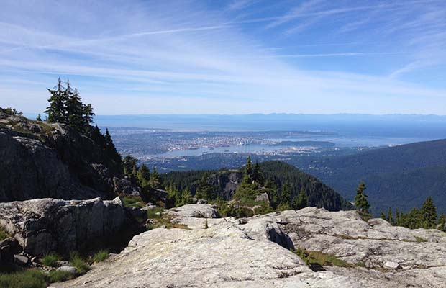

On August 10-12th, 2018, the YA ministry of Blue Mtn Church is going to the Chalet at Mt. Seymour for a rustic, beautiful weekend in retreat. We will spend time in silence + solitude, reflection and community. Come ready to hike, potentially swim, and grow!
Cost: $35
Bring:

Bible
Pillow/ Sleeping Bag or Sheets
Toiletries
Hiking clothes + shoes
- - - - - - - - - - - - - - - - - - - - - - - - - - - - - - - - - - - - - - - - - - - - - - - - - - - - - - - - - - - - - - - - - - - - - - - - - - - - - - - -
First Name:_______________________________ Last Name: ___________________________
Email: ___________________________________ Phone Number: ________________________
Food Allergies and Considerations: _____________________________________________________
Medical Concerns: ____________________________________________________________
Care Card Number: ____________________________________________________________
Emergency Contact (Name and Phone):_____________________________________________

